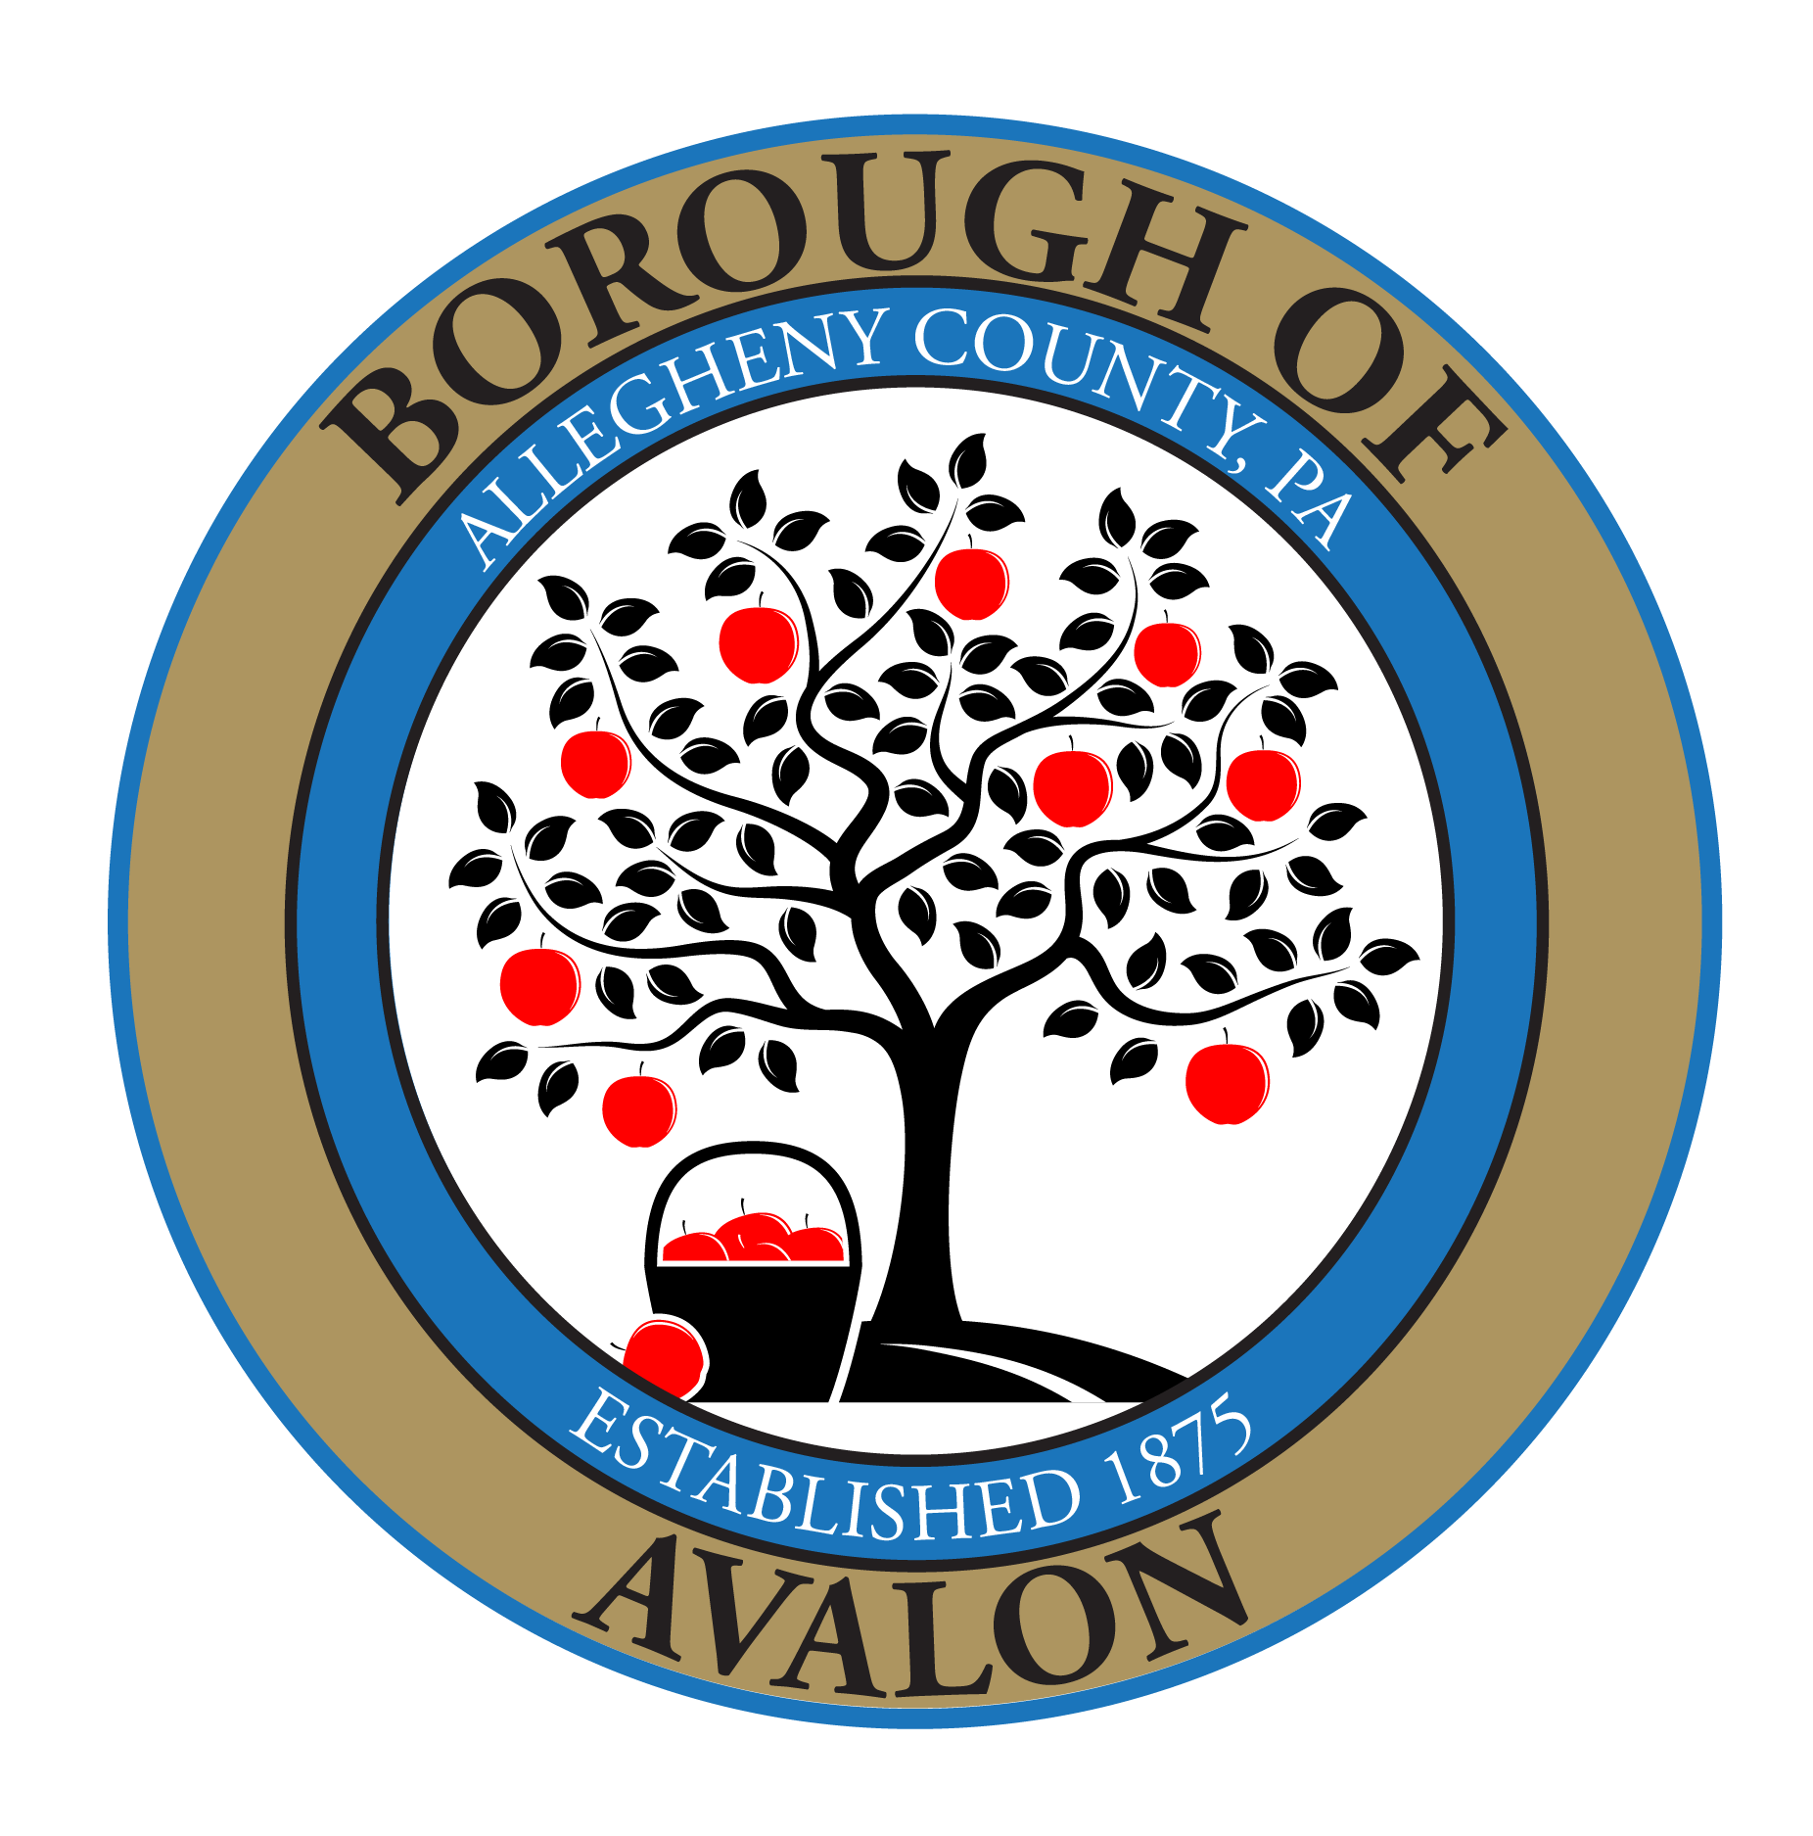
The Borough of Avalon Facility Rental
2024 Malt Beverage and Wine Permit Application
$100 Non-Refundable Permit Fee
Name of Responsible Party: ______________________________________________________________
Full Mailing Address:___________________________________________________________________ Phone:____________________________________ Email:__________________________________________ _____________________________________ Approximate number of persons attending: ________________
Check the statement relating to your event:

_____Minors WILL NOT be in attendance
_____Minors WILL BE in attendance and will not be served or permitted any malt beverages.

Conditions for Use:
Malt Beverage and Wine Permit must be completed and returned with rental permit application. Permit holder must be 21 years of age or older. Permit holder must attend and personally supervise the rental event for the duration of the event. Borough representatives will use the mobile number designated above to reach the permit holder during the rental event.
Alcohol shall be restricted to the permit area only. Beer shall only permitted be to be dispensed in cans or a keg. Only one (1) keg of any size is permitted. GLASS BOTTLES ARE NOT PERMITTED. Wine must be served in plastic glassware. No hard liquor is permitted at any time.
No alcohol will be served to persons less than 21 years of age or to any persons known to be intoxicated or exhibiting visibly noticeable intoxicated behavior. It shall be the permit-holder’s responsibility to enforce these restrictions. Permit holder agrees to be personally held responsible for any penalties, fines and/or criminal charges arising from the service of alcohol at the permitted event.
Permit holder specifically agrees to the following:
- The permit application must be turned in and paid for one week before the event.
- Permit holder will be held financially responsible for the cleanup of any debris related to alcohol consumption activity. A charge for actual labor and trucking will be billed to the permit holder when clean up beyond “broom clean condition” is necessary. These charges, along with any fines or penalties levied consistent with Borough Ordinances, Rules and Regulations will be the responsibility of the renter.
- Adherence to all other Borough of Avalon Facility Rental Rules, General Facility Rules and Regulations, and Park and Recreation Rules and Regulations.
- Bar closure shall occur at least thirty (30) minutes before event ends.
- Permit holder shall not sell or otherwise collect a fee from guests for alcohol served, unless licensed by the Pennsylvania Liquor Control Board.
The undersigned also agrees, on behalf of himself, his heirs, successors, or assigns and/or any organization he represents, its successors, assigns, members, participants and attendees at any function supported by this permit, to discharge, protect, release, indemnify and hold harmless the Borough of Avalon, its agents, officers, employees, elected and appointed officials, successors and assigns from any and all damages, injuries, demands, actions, claims, liabilities and expenses of any kind and nature whatsoever, including but not limited to costs of defense and attorneys’ fees, directly or indirectly arising out of or relating to or resulting from any personal injury (including death) or damages to any person or property damage of any kind arising from or anyway related to applicant’s use of this permit for the serving, possession and consumption of alcoholic beverages in the facility and parks of the Borough of Avalon.
Failure to strictly comply with all the above conditions will result in the immediate revocation of permit (without refund of any security deposit that may have been made). The Borough, by and through its agents, always maintains the sole discretion to direct all alcohol to be removed from the premises and/or the event to be terminated.
If the permit application is submitted on behalf of a group or organization, the undersigned certifies to the Avalon Borough that he/she is a duly authorized agent and representative of ___________________ (name of group/organization) and empowered to legally bind said group/organization to the above-stated terms and conditions.
I agree to all the above referenced terms and conditions for a Malt Beverage and Wine Permit.

_______________________________________ ______/______/______
Signature of Responsible Party Date

____ Permit APPROVED ________ Permit DENIED

____ Permit Fee Paid ($100) $_______ Cash Check # _________ CC_____

Borough of Avalon Employee Signature______________________________
Date ________________________________

